Bradbury House
Statement of Purpose

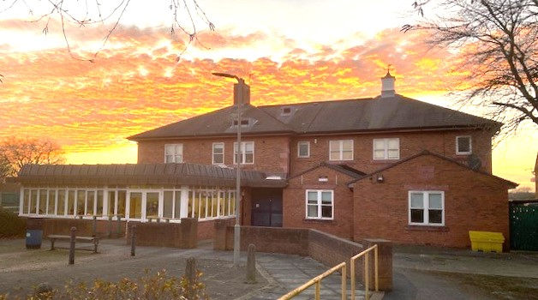

Contents Page No. 1. Welcome 3
2. Our Core Values and Aims 3 – 4
3. Our accommodation and location 4 – 5
4. The children and young people we care for 6
5. Admission to the house 6 – 7
6. Children’s Rights 7
7. Children’s Health and Care Planning 7 – 8
8. Children and Young People’s Therapeutic Care 8 – 9
9. Leadership and Management 9
10. Views, wishes and feelings 9 – 10
11. Supporting Cultural, Linguistic, Religious, Creative
and Physical Needs 10
12. Protection of Children and Young People 11
13. Enjoyment and Achievement 11 – 12

- Welcome to Bradbury House

Welcome to Bradbury House. We believe it is a very special place that is unique and purpose-built. It has 6 bedrooms and offers a home from home environment.

The house is registered with Ofsted as caring for children and young people with complex health needs. It is open Monday – Thursday term-time only.

Our staff are committed to supporting all children and young people in a manner that is centred and focused on their individual needs, interests and skills.

Parents and carers are encouraged to stay in touch with their children by telephone, text, email or facetime, or they can even pop in for a visit!

- Our Core Values and Aims

The pastoral care of all our pupils at the Royal School for the Blind is of paramount importance to us. The residential provision aims to provide a homely, caring, happy and stimulating environment for all the children and young people in our care. To encourage them to develop educationally, physically, socially and emotionally and to have fun!

Our core values:

• To always put the child first and to be child centred.
• To recognise, respect and celebrate each child as a unique individual.
• To deliver the highest quality of care in all that we do.
• Promote equality and diversity, to be open, fair and respectful of others.
• To safeguard our children following our policies and procedures.

The aim of the home is to keep children safe, give them the opportunity to enjoy and achieve, try to ensure that they reach their full potential and that their experiences within the home are positive.

- Our accommodation and location

Bradbury House is set in the heart of Wavertree community, opposite to Wavertree Mystery Park. The home has easy access to many other parks, shops, leisure clubs, cinemas, schools, and churches.

The home is a beautiful, detached house set within a caring community. The whole ambience of the home (decor, furniture, and accessories) encourages a feeling of family, warmth, stability, and security. It also has an accessible playground where children can play safely without leaving the premises.

Each child has their own bedroom allowing for both dignity, privacy and security. The rooms are fully furnished and provide a space to relax. Children are encouraged and supported to personalise and maintain their own rooms. The bedrooms are equipped with overhead tracking, specialised beds and ensuite bathrooms to accommodate children and young people who may have different care needs. All the rooms have TVs and music systems in place for children to access.
School and Grounds accessible to residential children
Accessible playground
Adapted bikes
Swimming pool
Soft play and sensory room.
Sports hall
Fully accessible food technology room
Ground Floor
Reception area
Lounge and relaxation area
Dining area
Kitchen
6 bedrooms – 3 ensuite rooms
3 bathrooms
Lift access to first floor

First Floor
3 on call staff accommodation rooms
Art and crafts room
Sensory room
Laundry room

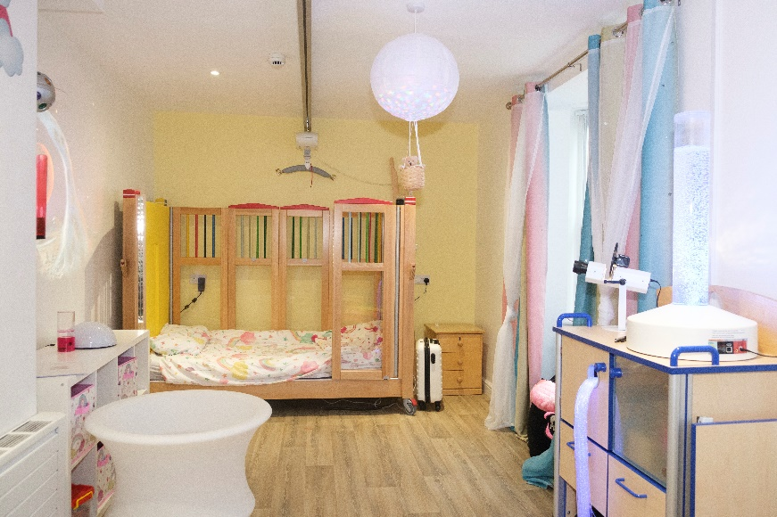

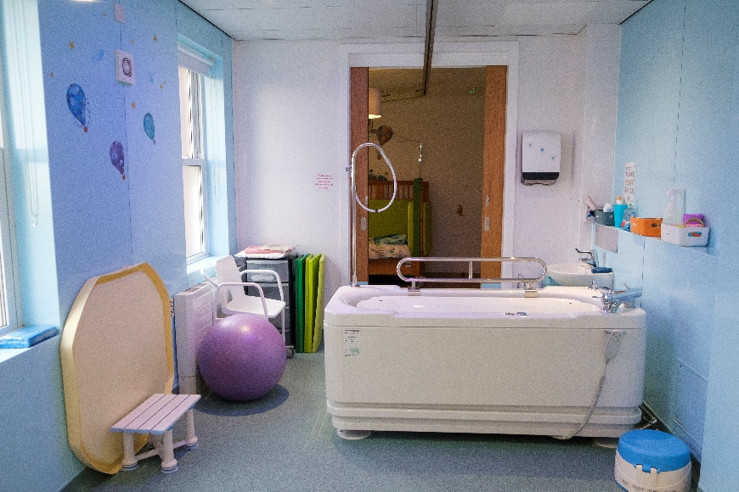

- The children and young people we care for

Our boarders can range from the ages of 5-19 years and are socially mixed. They are not grouped in ages as this would not be a true reflection of family life and a caring home environment which is what we strive for. The house caters for both our more-able children and children who have complex needs.

We are here to support and meet the needs of children and young people who live locally, regionally and nationally with a visual impairment, sensory and other additional needs. As a school we do not just focus on education, the team support the physical, social and spiritual needs of all of our children in a ‘team around the child’ (TAC) approach. We are flexible and accept change and think about how best to adapt our strategies and resources for each and every child in our care. We have a ‘whole child’ holistic attitude.

- Admission to the house

Residential/respite is only offered to children and young people attending the School. If parents/carers are interested in a respite placement then they need to contact the residential manager Amanda Boyle to make an appointment to discuss this. Respite nights are funded by social care through a designated social worker. If the house is full you will need to go on the waiting list. All the necessary consents and information needed to admit the child should be provided before admission but the manager will go through this with you. Parents/carer are encouraged to visit the house and meet the staff.

Once the placement has been agreed, the child will come for teatime visits with a member of staff from their class and who they are familiar with. How long it will take to settle will depend on the child. The residential team will work with the child and the family to arrange a transition plan. The visits will also allow the child and staff to get to know each other and for the child to explore the house.

- Children’s Rights

The rights of each young person are acknowledged and respected - age, ethnicity, religious background, gender, disability or sexuality. The team work closely with social workers and also ensure that all children and young people know about and have access to an independent visitor and a key worker.

We believe that all children who board with us have the right to have their say and to make a difference to the care they receive. Children and young people are encouraged to access an independent visitor if they want to discuss their care and have access to contact details for Careline. The independent visitor visits the house, children and staff every half-term.

- Children’s Health and Care Planning

We monitor and record details related to the overall health and wellbeing of each child and are mindful of the following:

  - Health history (past illness, operations, vaccinations, immunisations, allergies, developmental milestones, prescribed medication, current treatments)
  - Diet
  - Dental care
  - Optical care
  - Side effects of any medication

It is the policy of the school/residential to ensure that the quality of care offered to the children is of the highest quality in order that their uniquely individual needs are met.

All staff administering medications are trained and deemed competent by a fully qualified children’s nurse. The staff work closely alongside each other, school, other professionals, and parents to ensure continuity of care for each child. All children are listened to and encouraged to be involved in all aspects of their care and residential life.

- Children and Young People’s Therapeutic Care

Complementing our commitment to ensuring the health and safety of children in our care is our belief in the effectiveness of therapy as part of providing the best overall treatment for each child. In providing therapy we place the child at the centre of our thinking.

Some of our children have complex needs so we work on stages of development not ages when planning activities and setting targets. We link in with the early years framework and believe all children learn through play and socialising with others of different ages and abilities.

We provide care that will help children within our homes to develop both the social and life skills that will enable them to live safely and productively in the community. Each child has individually tailored care, education and therapy programmes and ensure that the collaborative practices between care, therapy and educational staff provide the children with consistency and security.

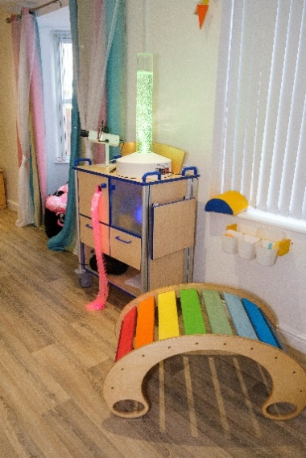

- Leadership and Management

The manager of Bradbury House is Amanda Boyle and her deputy is Faye Nettleton. The independent visitor is Clare Geraghty and the nominated care governor is Helen Casstles.

Bradbury House will operate with a minimum number of staff on duty during the morning and evening and waking night staff are supported by a staff member on-call. This is consistently reviewed as the numbers of children within the house and their individual needs change nightly. A senior manager will always be on-call outside of office hours to offer support and guidance to the team on duty and handle any site emergencies.

We have staff who are EYFS trained, have NVQ level 3 or equivalent. The manager holds NNEB and Management qualifications. More importantly they all have a vast experience in visual impairments, mobility and life skills and working with children with complex needs.

- Children’s views, wishes and feelings

All of the children are treated with warmth, respect and dignity. Their voice is always heard! Along with an ethos of respect for others, cultural, religious or non- religious beliefs being an essential part of their care.

All children are encouraged to be as independent as possible in all aspects of daily life.

In Bradbury House we have house meetings when the children have another opportunity to express any concerns, choices, preferences or positive opinions. The children and staff talk about what is going well, what isn't and how we can improve the way we all live together at the house.

- Supporting Cultural, Linguistic, Religious, Creative and Physical Needs

We consider the cultural, religious and spiritual needs of our children as being central to their identity and welfare. We are proactive in supporting them to fulfil their identities. At the time the child is admitted to Bradbury House, the residential team will have met the child and their family to identify areas of need in relation to culture, language and religious observance. We will do our utmost to provide for dietary requirements related to an individual’s religion and would encourage dress that reflected their beliefs.

Any specific religious belief or faith practiced by a child will be recognised, respected and every effort made to ensure that the appropriate local place of worship is available so that the child can participate in religious observance appropriate to their age.

We also understand the importance of peer relationships during
adolescence and that belonging to groups can help a young person to find their own identity. We encourage young people to integrate with clubs in the local area, obviously following risk assessments and safeguarding procedures.

- Protection of Children and Young People

Bradbury House is committed to following government guidelines throughout their practice in order to keep staff and children safe, and reduce any unnecessary risks.

Safeguarding of everyone is paramount and the school and residential has individual policies to cover every aspect of keeping children safe. These cover a wide spectrum including risk assessments and staff recruitment. Keeping children safe in education is a document that all staff are familiar with and are regularly directed to during supervisions and staff meetings in particular Part one and Annex A.

Its core principles are underpinned by the National minimum standards and the SCCIF framework for residential special schools.

We pride ourselves on a safe caring environment which promotes independence and a caring attitude to others and adopt an attitude of ‘we can and we will’.

- Enjoyment and Achievement

Bradbury House provides an open and honest learning environment for children and staff allied to promoting and encouraging respect for each other and promoting positive relationships with others.

A healthy lifestyle is encouraged for all children and young people. We recognise that for some children will need additional support to ensure they participate and access quality leisure and social time. We have access to transport to increase the opportunities for everyone to enjoy and participate in fun and leisure-based activities together. We believe this helps build relationships and provides another opportunity for social learning, building self-esteem, confidence and trust. Children are also supported in attending important religious and cultural festivals if they wish.

Within Bradbury house, staff offer a range of structured and non-structured activities such as arts and crafts, computer games consoles, swimming, soft play, sensory room, food technology, board/card games and social trips out to the theatre, music venues, cafes. Activities involving risk will be carefully risk assessed beforehand. Activities are always tailored to suit the individual child and their interests and choices.

Statement of Purpose written by:
Care team managers:
Linda Hogan - Head of Care
Kaie Samoilov - Deputy Head of Care
Amanda Boyle - Residential manager
20/1/2023

